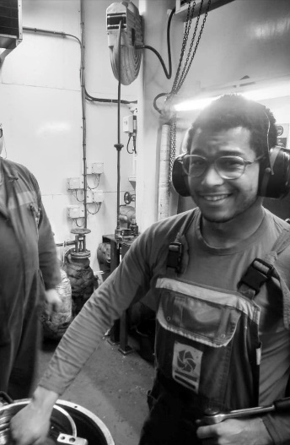
Henrique Van Mol

Date of birth: 22 September 2001
Belgian nationality
Contact:
Tel: 0474 51 29 56
e-mail: RikVanMol2@gmail.com
Hondelee 12 ,9052 zwijnaarde (Gent)

PROFILE
My passion is working in the engine room of a ship, working with the crew and thus growing in the job of a ship engineer. A challenging work environment is no problem for me. I am very interested in new technologies and innovative projects within the maritime sector.
I work accurately and with care on machines.
I am flexible on board and a team player.

Studies
- Specialization first and 2nd year: Electro-mechanics Edugo de brug - Ghent
- specialization 3rd > 6th year: marine engineering Maritime School Cenflumarin -Antwerp

Certificates & courses
STCW Certficate of Competence | ISSUED DATE | EXPIRY DATE | AUTHORITY
STCW III/I OFFICER IN CHARGE OF ENGINEERING WATCH | 16/01/2023 | 16/01/2028 | BE - Belgium
Certificates of Proficiency

STCW VI/6-1 Security Awareness | 17/07/2020 | 31/12/2099 | BE - Belgium

- Fire Prevention and Fire Fighting (VDAB Maritime training) valid until 26 may 2026
- High voltage Safety course (Antwerp Maritime Academy)
- Basic first aid
- limited certificate from radio operator of shipping stations (BIPT – IBPT)
- In possession of driving licence B
- Certificate maritime deck crane operator (SOMA bedrijfsopleiding)
- VCA basic safety course

PERSONAL DOCUMENTS
TYPE | NUMBER | ISSUED DATE | EXPIRY DATE | AUTHORITY | PLACE
PASSPORT | ES029203 | 6/12/2019 | 5/12/2026 | BE - Belgium | Gent
SEAMAN’S BOOK | 202000868 | 17/07/2020 |  | BE - Belgium | Antwerp
Certificate of medical fitness | 078 | 16/07/2020 | 16/07/2021 | BE - Belgium | Antwerp

My work experience
- Dredging International NV (DEME) /march 2021 – present/
2022-…: I am working on the Uilenspiegel as 3th engineer.
2021-2022: on the Scheldt river , Pallieter and Breughel as 3th engineer
- Ship support technics /october 2020 – march 2021 /
Working as a Service engineer ( small engine maintenance on sailing ships and other vessels)
- Boluda towage /2018/
Contract of 12 days as deckhand
- 2016 2020 : different student worker -jobs
- 2019: warehouse worker - Gates ( 2 weeks)
- 2018 : jobstudent waiter, and cleaner - Brasserie Rubens (2 weeks)
- 2017 + 2020: Jobstudent bandwork - Roomer (for one week, each)
Internship
2016 – 2020 : internship with Vloot on utility ship Sirius and school ship Themis, Tijl
- Maintenance rounds
- Maintenance and painting on ship
- Fire fighting and MOB exercises

Computer knowledge and languages
- e-mail, social media, Windows, Word, Powerpoint
- Basic knowledge SketchUp
- language: Dutch , Basic French and English

My hobbies :
- Sea scouts De Wilde eend , Ghent (3x Quarter leader, totem: zealous Gaur)
- Canoepolo, European championship 2019 (National U21 team)

